Aim: Practical based on Interacting with Web APIs
IDE:
To interact with web APIs using Python and libraries like requests. The practical will involve making GET and POST requests, handling responses, and parsing JSON data.
Library Installation
pip install requests
Select an API: Choose a public API for testing. For this tutorial, we’ll use the JSONPlaceholder API, a free fake online REST API for testing and prototyping.
Making a GET Request
Fetch a list of posts.
import requests

# Define the API endpoint
url = 'https://jsonplaceholder.typicode.com/posts'

# Make a GET request
response = requests.get(url)

# Check the status code
if response.status_code == 200:
# Parse JSON response
posts = response.json()
print("Fetched Posts:")
for post in posts[:5]: # Print the first 5 posts
print(f"Title: {post['title']}")
else:
print(f"Failed to retrieve posts. Status code: {response.status_code}")
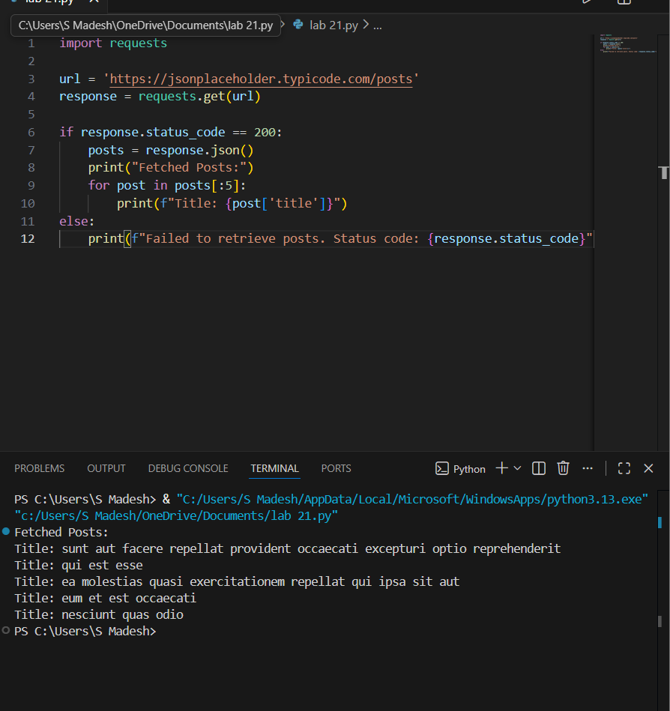
Making a POST Request
Create a new post.
import requests

# Define the API endpoint
url = 'https://jsonplaceholder.typicode.com/posts'

# Define the data to send
new_post = {
"title": "My New Post",
"body": "This is the content of my new post.",
"userId": 1
}

# Make a POST request
response = requests.post(url, json=new_post)

# Check the status code
if response.status_code == 201:
# Parse JSON response
created_post = response.json()
print("Created Post:")
print(f"Title: {created_post['title']}")
print(f"Body: {created_post['body']}")
else:
print(f"Failed to create post. Status code: {response.status_code}")
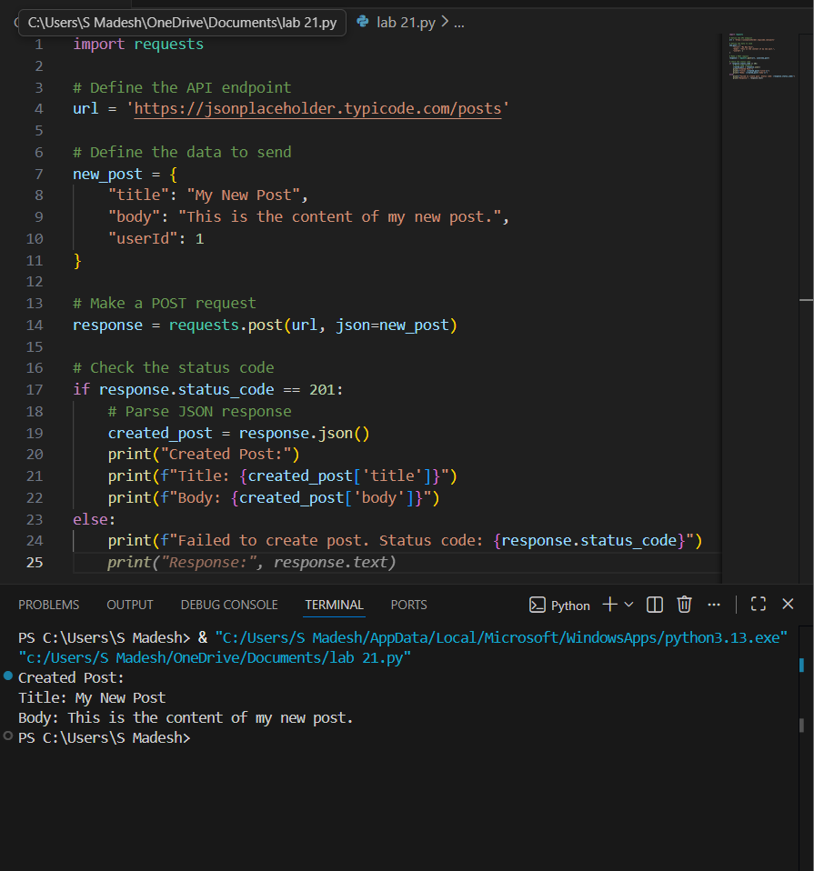
Error Handling
Handle potential errors in API requests.
import requests

url = 'https://jsonplaceholder.typicode.com/posts/1000' # Non-existent post

response = requests.get(url)

if response.status_code == 200:
post = response.json()
print("Fetched Post:", post)
else:
print(f"Error: {response.status_code} - {response.reason}")
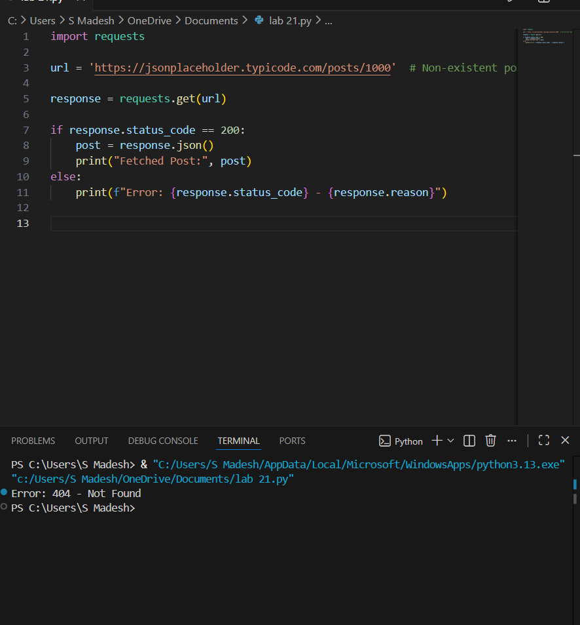

Post Lab:
Building a Simple API Client (Write a simple Python class that encapsulates the functionality for making GET and POST requests to the JSONPlaceholder API. Include methods for fetching posts and creating a new post.)
